Tilak Maharashtra Vidyapeeth (TRUST)
LOKMANYA TILAK COLLEGE OF PHYSIOTHERAPY
Affiliated to MUHS
Plot No.3, Sector 14, Near Raghunath Vihar, Kharghar, Navi Mumbai, 410210.
Email ID : lokmanyamcop@gmail.com / administration@lmcop.edu.in
Website : http://www.lmcop.edu.in
REPORT OF CAMP ACTIVITY AT UPHC KALAMBOLI ON 28TH OF DECEMBER 2021.
TOPIC: Camp Activity at UPHC Kalamboli. Health Assessment program carried out by 4th year students and Interns.
VENUE: UPHC, Kalamboli, Kamothe, Sector-14. DATE: 28th December 2021.
PRINCIPAL AS ORGANIZER: Dr. Shweta Phadke.
COORDINATORS: Dr. Jyoti Parle and Dr. Sabina Hakim.
PHOTOGRAPHS INCLUDED: Yes.
Report of the Event
A health camp was organized by Lokmanya Tilak College of Physiotherapy in association with Panvel Mahanar palika , UPHC, Kamothe, Sector-14. The Health camp commenced at 9:00 am, which was followed by registration of every patient at Registration Booth. Every patients Height, Weight and BMI were measured and an information sheet regarding the same was provided to them. Additionally, Fatigue Severity Score (FSS) and Nordic Musculoskeletal Questionnaire (NMQ) were assessed and Body Composition Analysis was measured using TANITA machine. The assessment of Women's health was done with the help of Questionnaire which was duly filled. Also Geriatric assessment of fall and environmental taken by interns and final year students. Behind every information sheet, the address of the College OPD was given along with the address of UPHC, Kalamboli for patients staying farther away for reference and follow up purposes. More than 100 participant took the benefit of this Physiotherapy camp.The camp concluded at 2:45 pm in afternoon, following which the students reported back to college at 3:00 pm.
The information gathered will be useful in assessing the general health condition of the population in and around the Kamothe area. A proper and informed referral service will be useful to treat the patients as an outreach program.

Dr, Jyoti Parle,
Professor& HOD,
Lokmanya Tilak College of Physiotherapy,
Kharghar, Navi Mumbai.

Dr. Shweta Phadke,
Professor& Principal,
Lokmanya Tilak College of Physiotherapy,
Kharghar, Navi Mumbai.
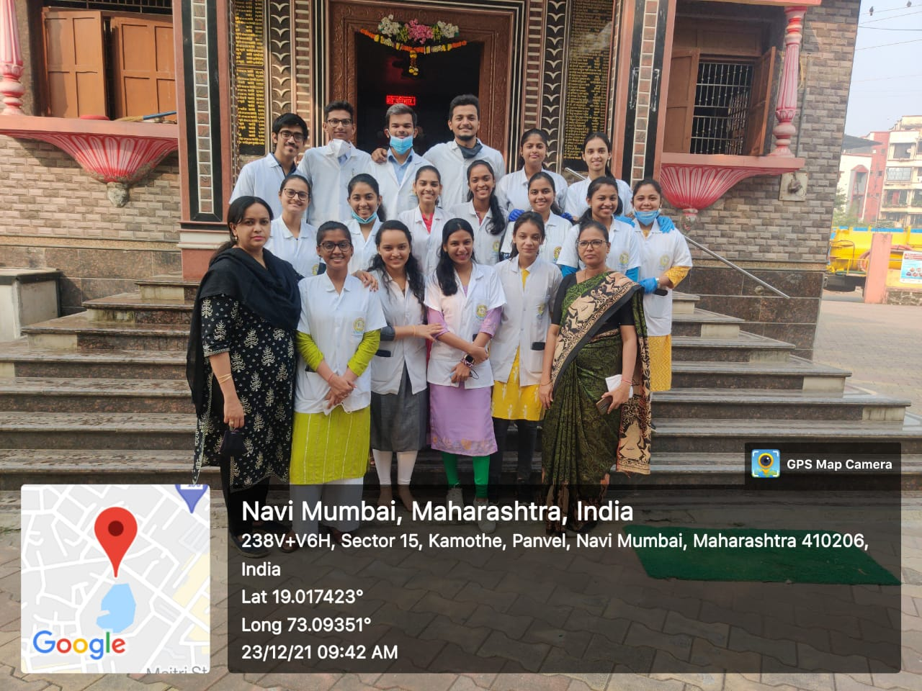
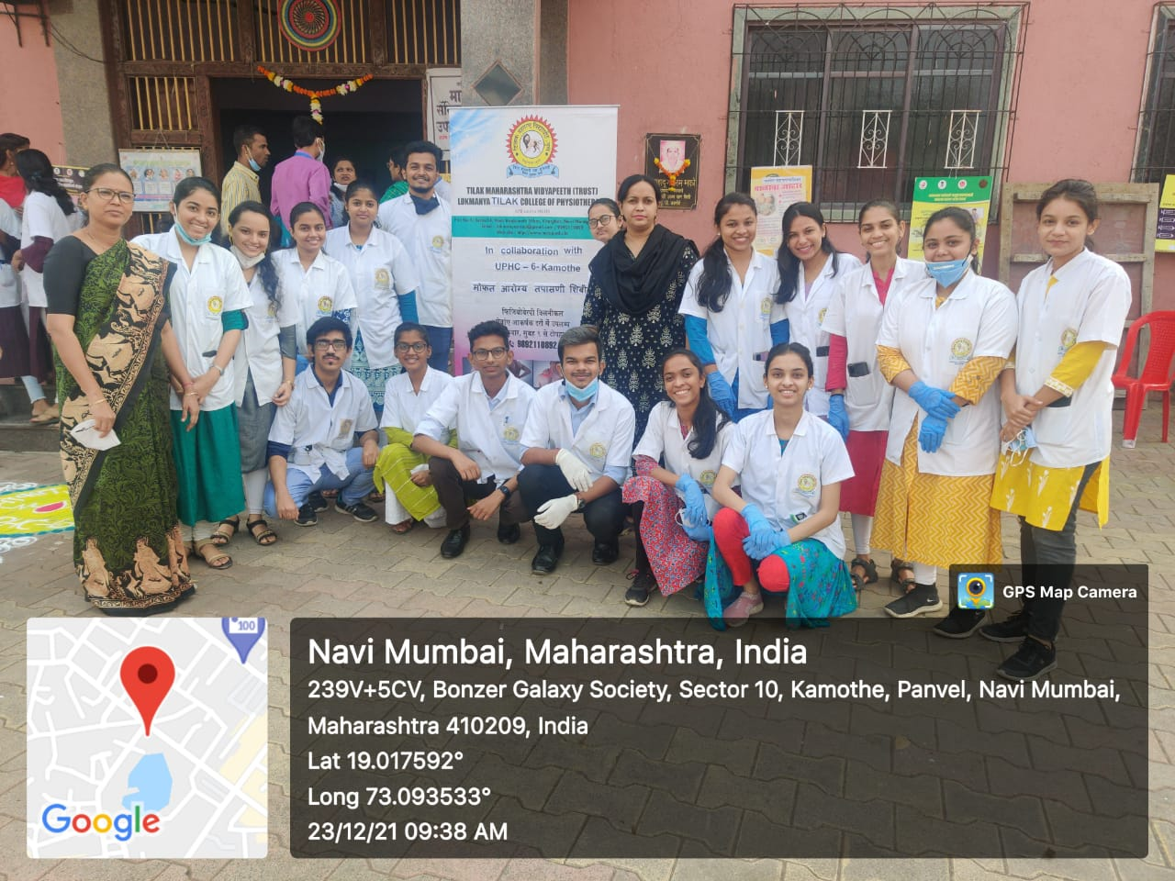

Tilak Maharashtra Vidyapeeth (TRUST)
LOKMANYA TILAK COLLEGE OF PHYSIOTHERAPY
Affiliated to MUHS
Plot No.3, Sector 14, Near Raghunath Vihar, Kharghar, Navi Mumbai, 410210.
Email ID : lokmanyamcop@gmail.com / administration@lmcop.edu.in
Website : http://www.lmcop.edu.in
REPORT OF INAUGURATION OF PHYSIOTHERAPY OPD AT UPHC KHARGHAR ON 15TH OF FEBRUARY 2022.

TOPIC: Inauguration of Physiotherapy OPD at Kharghar UPHC
VENUE: UPHC, Kharghar, Sector-15. DATE: 15th February 2022.
PRINCIPAL AS ORGANIZER: Dr. Shweta Phadke.
COORDINATORS: Dr. Jyoti Parle and Dr. Sabina Hakim.
PHOTOGRAPHS INCLUDED: Yes.
Report of the Event
Inauguration of Physiotherapy OPD at Kharghar UPHC, Sector 15, on 15th of Feb. 2022, Tuesday, with Panvel Mahanagar Palika. On the occasion of inauguration all distinguished guests were present. Ribbon cutting ceremony was done by Corporator Mr, Naresh Thakur in presence of Mr. Paresh Thakur, Hono. Commissioner Mr. Ganesh Deshmukh, Mayor Mrs. Kavita chautmal and Cheif Medical Officer Dr. Anand Gosavi. Inauguration Program attended by Dr. Shweta Phadke,Professor & Principal and Professor & HOD of Dept. Of Community PT. Dr. Jyoti Parle, and Assit. Professor Dr. Sabina Hakim,with Final year BPTh and Intern students.
Services provided in this OPD all musculoskeletal problems of all age group, ANC and PNC care with post covid rehabilitation. We appreciate Panvel Mahanagar Palika’s vision to collaborate with lokmanya Tilak college of Physiotherapy and start Physiotherapy OPD at Kharghar UPHC under PMC. This will open preventive and promotive heath care doors for needy people.

Thank you

Dr, Jyoti Parle, Dr. Shweta Phadke,
Professor& HOD, Professor& Principal,
Lokmanya Tilak College of Physiotherapy, Lokmanya Tilak College of Physiotherapy,
Kharghar, Navi Mumbai Kharghar, Navi Mumbai.

.



